circle_exploration.clean

Circle Exploration
Detailed analysis of individual recovery circles: engagement trends, circle size, disenrollments, and a summary scorecard.
Circles are ranked by Bayesian-adjusted engagement rate — smaller/newer circles are pulled toward the overall average so they don't rank artificially high.
2557 records, 344 members, 21 circles
14 weeks: 2025-12-01 to 2026-03-16

1. Engagement Rate, Circle Size, and Disenrollment Over Time
Each subplot shows engagement rate (green line, left axis), enrolled members (blue bars, right axis), and disenrollments (red bars stacked on blue, right axis) per circle per week. The subtitle shows raw and adjusted engagement rate, average circle size, and total disenrollments for each circle.
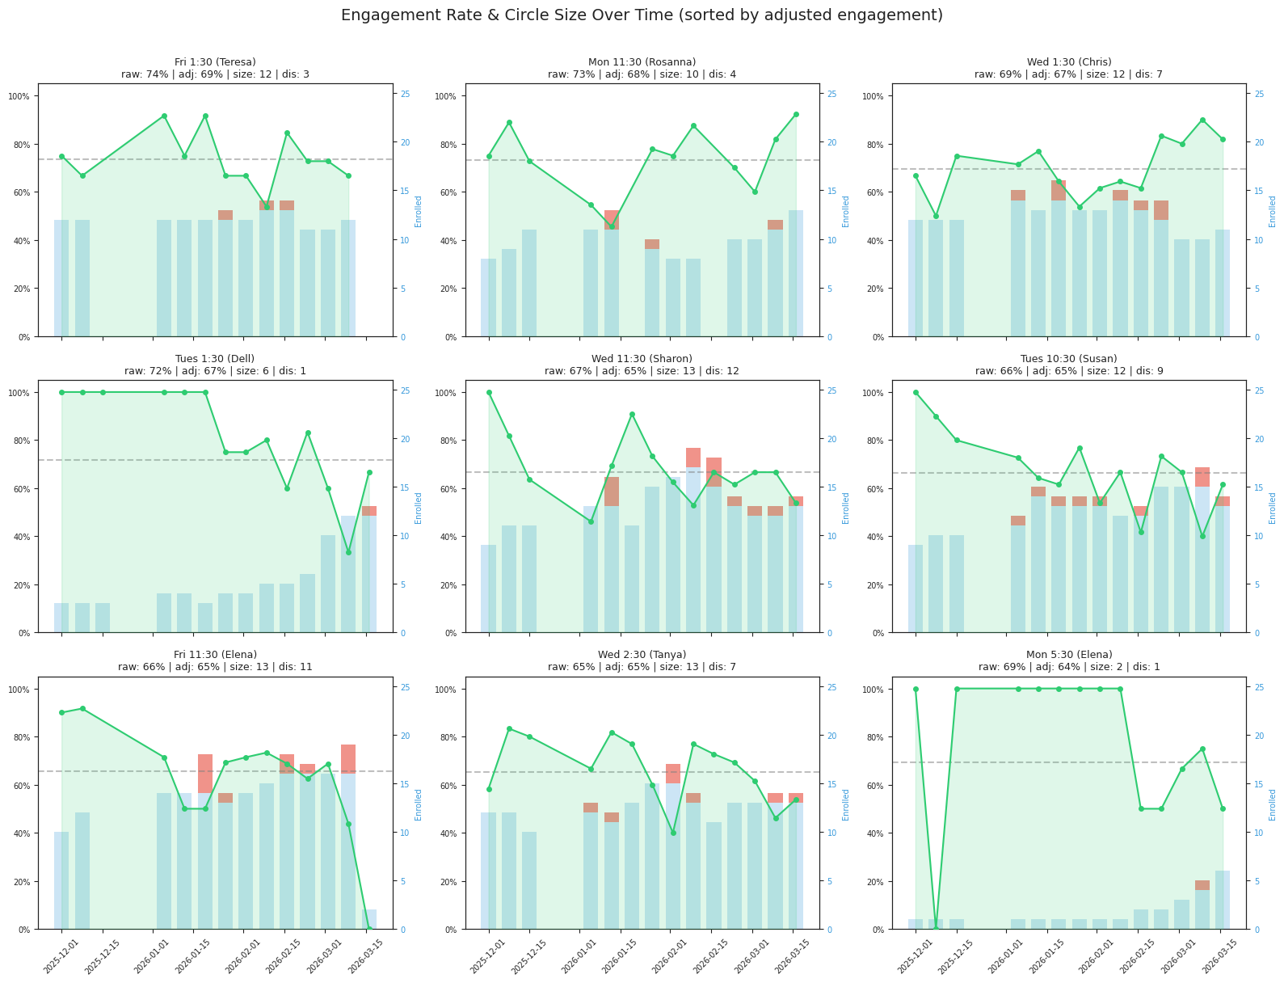
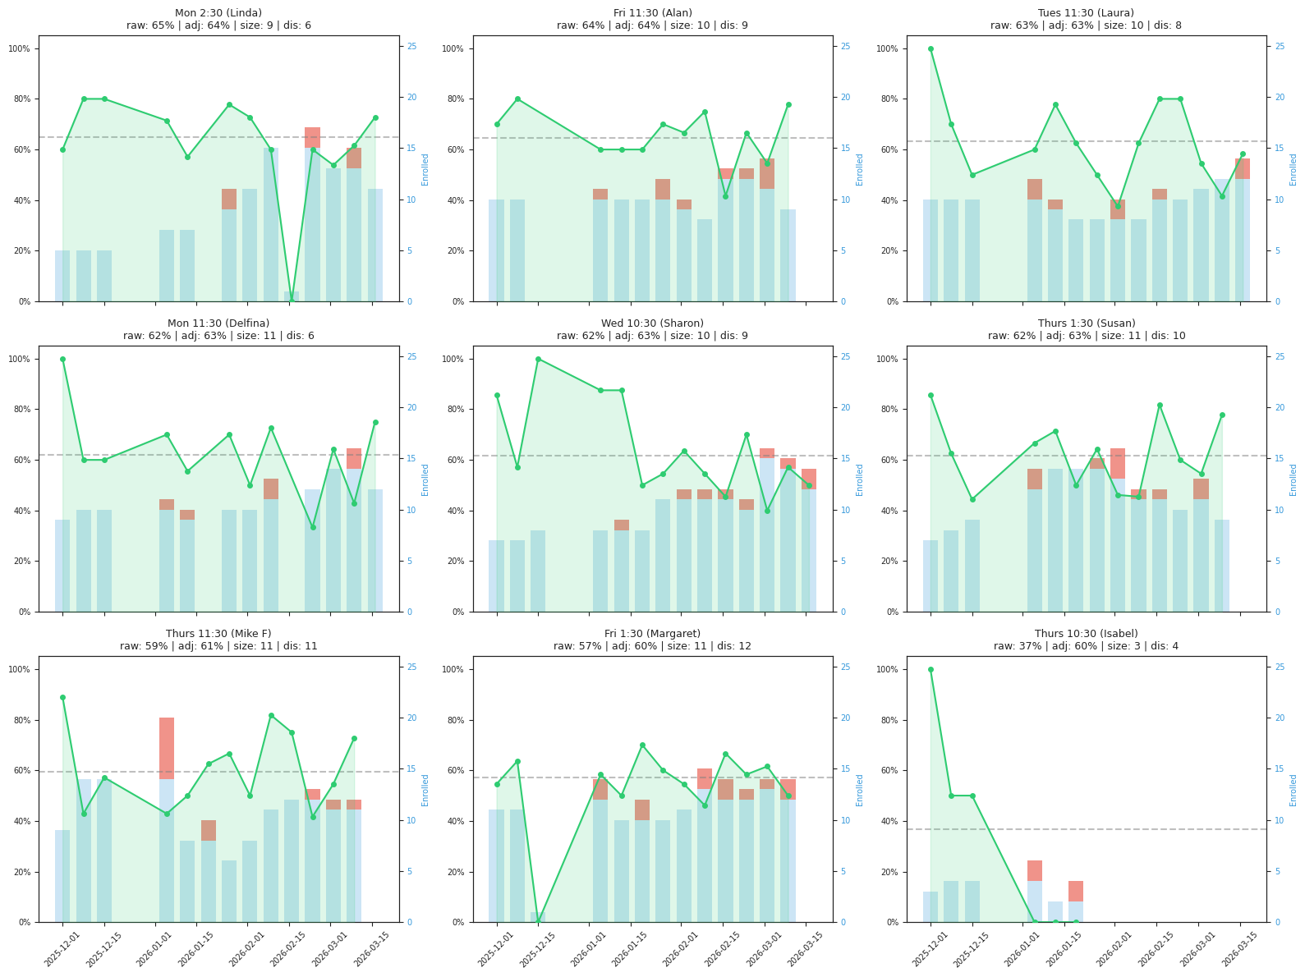
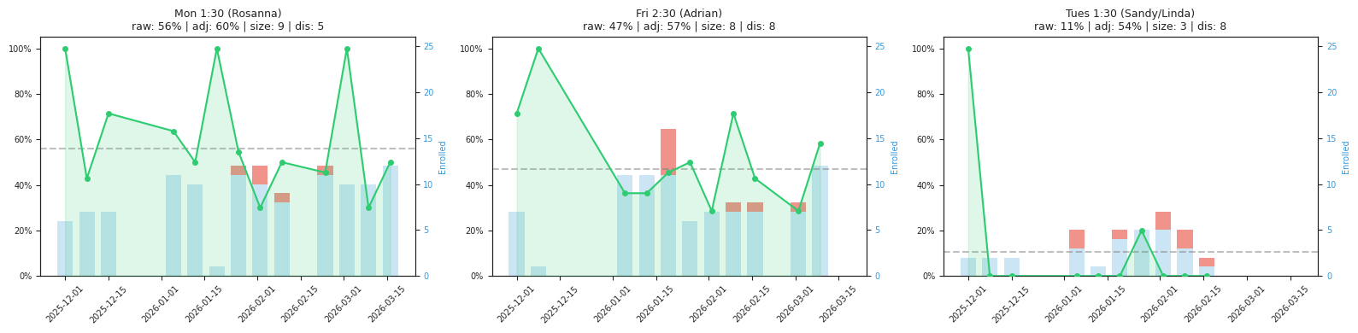
Blue bars = enrolled members | Red bars = disenrollments that week | Green line = engagement rate
Engagement rates adjusted for circle size using Bayesian averaging (C=136, M=64%).
Smaller/newer circles are pulled toward the overall average; larger circles keep their own rate.

2. Circle Summary
Sorted by adjusted engagement rate. Adjusted for circle size using Bayesian averaging — smaller/newer circles are pulled toward the overall average (64%), so they don't rank artificially high from limited data.
Circle | Members |  |  | Engagement |  | Disenrollment |  | At Risk (1 miss) |  | Ineligible (2+)
Circle | Curr | Tot | Wks | Raw | Adj | Cnt | Rate | Cnt | % Curr | Cnt | % Curr
Fri 1:30 (Teresa) | 12 | 15 | 12 | 74% | 69% | 3 | 20% | 3 | 25% | 1 | 8%
Mon 11:30 (Rosanna) | 13 | 17 | 12 | 73% | 68% | 4 | 24% | 0 | 0% | 1 | 8%
Wed 1:30 (Chris) | 12 | 19 | 14 | 69% | 67% | 7 | 37% | 3 | 25% | 0 | 0%
Tues 1:30 (Dell) | 11 | 12 | 14 | 72% | 67% | 1 | 8% | 0 | 0% | 3 | 27%
Wed 11:30 (Sharon) | 12 | 24 | 14 | 67% | 65% | 12 | 50% | 4 | 33% | 1 | 8%
Tues 10:30 (Susan) | 12 | 21 | 14 | 66% | 65% | 9 | 43% | 2 | 17% | 2 | 17%
Fri 11:30 (Elena) | 13 | 24 | 13 | 66% | 65% | 11 | 46% | 5 | 38% | 2 | 15%
Wed 2:30 (Tanya) | 11 | 18 | 14 | 65% | 65% | 7 | 39% | 3 | 27% | 1 | 9%
Mon 5:30 (Elena) | 6 | 7 | 14 | 69% | 64% | 1 | 14% | 3 | 50% | 0 | 0%
Mon 2:30 (Linda) | 11 | 17 | 13 | 65% | 64% | 6 | 35% | 2 | 18% | 1 | 9%
Fri 11:30 (Alan) | 8 | 17 | 12 | 64% | 64% | 9 | 53% | 0 | 0% | 2 | 25%
Tues 11:30 (Laura) | 10 | 18 | 14 | 63% | 63% | 8 | 44% | 2 | 20% | 1 | 10%
Mon 11:30 (Delfina) | 12 | 18 | 12 | 62% | 63% | 6 | 33% | 1 | 8% | 2 | 17%
Wed 10:30 (Sharon) | 12 | 21 | 14 | 62% | 63% | 9 | 43% | 4 | 33% | 2 | 17%
Thurs 1:30 (Susan) | 9 | 19 | 13 | 62% | 63% | 10 | 53% | 1 | 11% | 1 | 11%
Thurs 11:30 (Mike F) | 10 | 21 | 13 | 59% | 61% | 11 | 52% | 2 | 20% | 0 | 0%
Fri 1:30 (Margaret) | 10 | 22 | 13 | 57% | 60% | 12 | 55% | 4 | 40% | 0 | 0%
Thurs 10:30 (Isabel) | 0 | 4 | 6 | 37% | 60% | 4 | 100% | 0 | 0% | 0 | 0%
Mon 1:30 (Rosanna) | 12 | 17 | 13 | 56% | 60% | 5 | 29% | 0 | 0% | 6 | 50%
Fri 2:30 (Adrian) | 12 | 20 | 11 | 47% | 57% | 8 | 40% | 2 | 17% | 3 | 25%
Tues 1:30 (Sandy/Linda) | 0 | 8 | 10 | 11% | 54% | 8 | 100% | 0 | 0% | 0 | 0%
Column descriptions:
Column | Description
Circle | Recovery circle name (day, time, facilitator)
Curr | Members currently enrolled in the circle
Tot | All members ever in the circle (current + disenrolled)
Wks | Number of weeks with attendance data
Raw | Raw engagement rate: weeks attended / weeks enrolled (X only)
Adj | Adjusted engagement rate (Bayesian average) — accounts for circle size so small/new circles don't rank artificially high
Disenroll Cnt | Number of members disenrolled from this circle
Disenroll Rate | Disenrollment rate: disenrolled / total members
At Risk Cnt | Current members with exactly 1 consecutive miss (A or E) — one more triggers ineligibility
At Risk % Curr | Percentage of current members at risk
Ineligible Cnt | Current members with 2+ consecutive misses — in cool-down period
Ineligible % Curr | Percentage of current members ineligible

