kpi_exploration.clean

KPI Exploration
Key performance indicators for the membership program.
Context: RCSJ's model accepts that members may join, leave, and rejoin multiple times. Disenrollment is not a failure — it's part of the process. We're looking for metrics that measure engagement quality and can track the impact of improvement projects.
2557 records, 344 members, 21 circles
14 weeks: 2025-12-01 to 2026-03-16

1. Active Engagement Rate
Of enrolled members each week, what % actually attended? Green line shows engagement rate (left axis). Blue bars show total enrolled members and red bars show disenrollments that week (right axis).
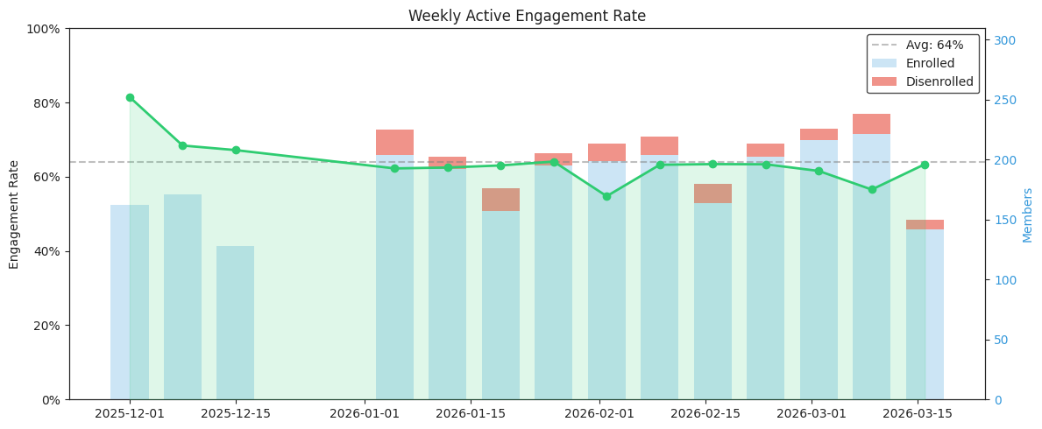

 | Week | Enrolled | Attended | Rate | Disenrolled
0 | 12-01-25 | 162 | 132 | 81% | 0
1 | 12-08-25 | 171 | 117 | 68% | 0
2 | 12-15-25 | 128 | 86 | 67% | 0
3 | 01-05-26 | 204 | 127 | 62% | 21
4 | 01-12-26 | 192 | 120 | 62% | 10
5 | 01-19-26 | 157 | 99 | 63% | 19
6 | 01-26-26 | 195 | 125 | 64% | 10
7 | 02-02-26 | 199 | 109 | 55% | 14
8 | 02-09-26 | 204 | 129 | 63% | 15
9 | 02-16-26 | 164 | 104 | 63% | 16
10 | 02-23-26 | 202 | 128 | 63% | 11
11 | 03-02-26 | 216 | 133 | 62% | 10
12 | 03-09-26 | 221 | 125 | 57% | 17
13 | 03-16-26 | 142 | 90 | 63% | 8

2. At-Risk Rate (Approaching Ineligibility)
Members with exactly 1 consecutive miss (absent or excused) are one circle away from becoming ineligible. Tracking this rate over time shows whether the population of at-risk members is growing or shrinking.
This uses the same eligibility logic as the Intervention notebook:
- A miss = absent (A) or excused (E). Only attended (X) resets the count.
- 1 consecutive miss = at-risk. 2+ = ineligible (cool-down triggered).
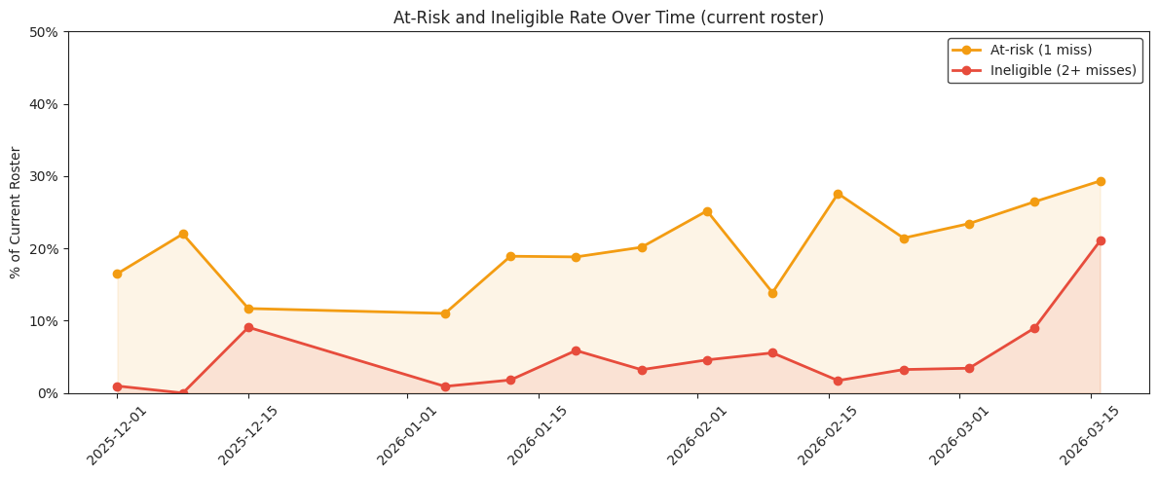
Latest week (2026-03-16):
Enrolled: 133
At-risk (1 miss): 39 (29%)
Ineligible (2+ misses): 28 (21%)

3. Weeks Engaged Per Enrollment
For disenrolled members: how many weeks did they actively attend before being disenrolled? If improvement projects work, this number should increase over time.
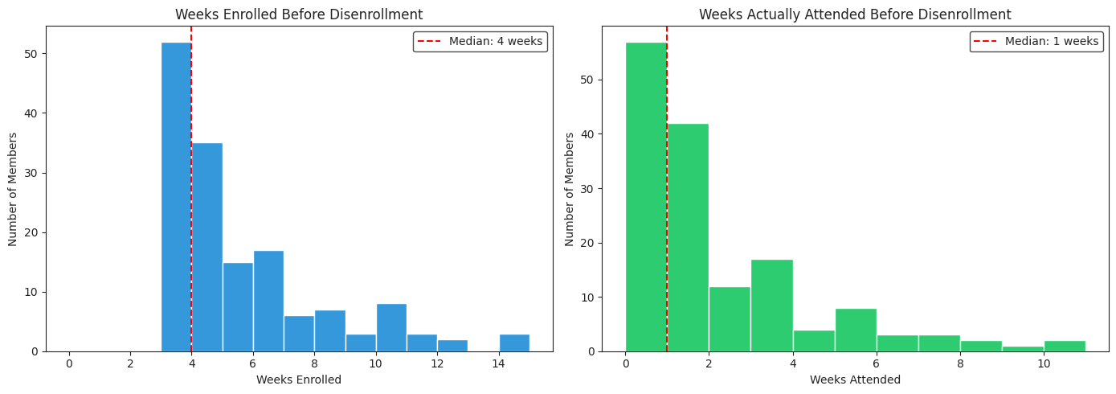
Engagement duration by disenrollment month:

 | dis_month | count | median_weeks_enrolled | median_weeks_attended | dis_month_str
0 | 2026-01 | 60 | 4 | 1 | 2026-01
1 | 2026-02 | 56 | 5 | 1 | 2026-02
2 | 2026-03 | 35 | 3 | 0 | 2026-03

