membership_analysis.clean

RCSJ Membership Analysis
Circle attendance patterns and disenrollment trends for Recovery Cafe San Jose.
2557 attendance records, 344 members, 21 circles
Date range: 2025-12-01 to 2026-03-16

Overall Attendance Rate by Month
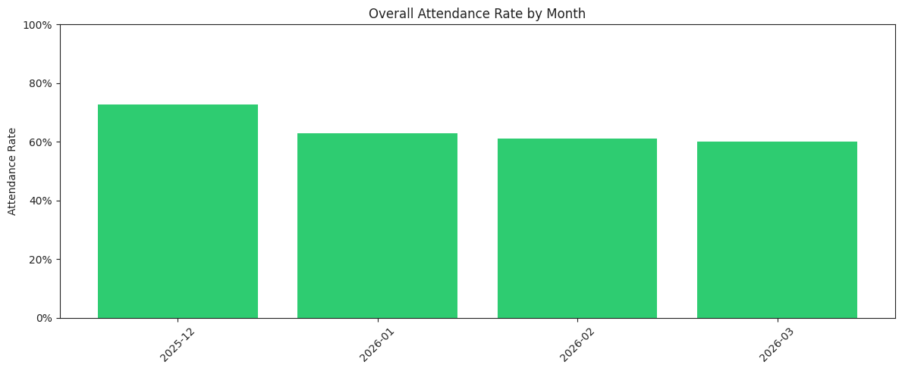

 | month_str | total | present | absent | excused | attendance_rate
0 | 2025-12 | 461 | 335 | 76 | 50 | 0.7
1 | 2026-01 | 748 | 471 | 214 | 62 | 0.6
2 | 2026-02 | 769 | 470 | 216 | 82 | 0.6
3 | 2026-03 | 579 | 348 | 172 | 57 | 0.6

Attendance Rate by Circle
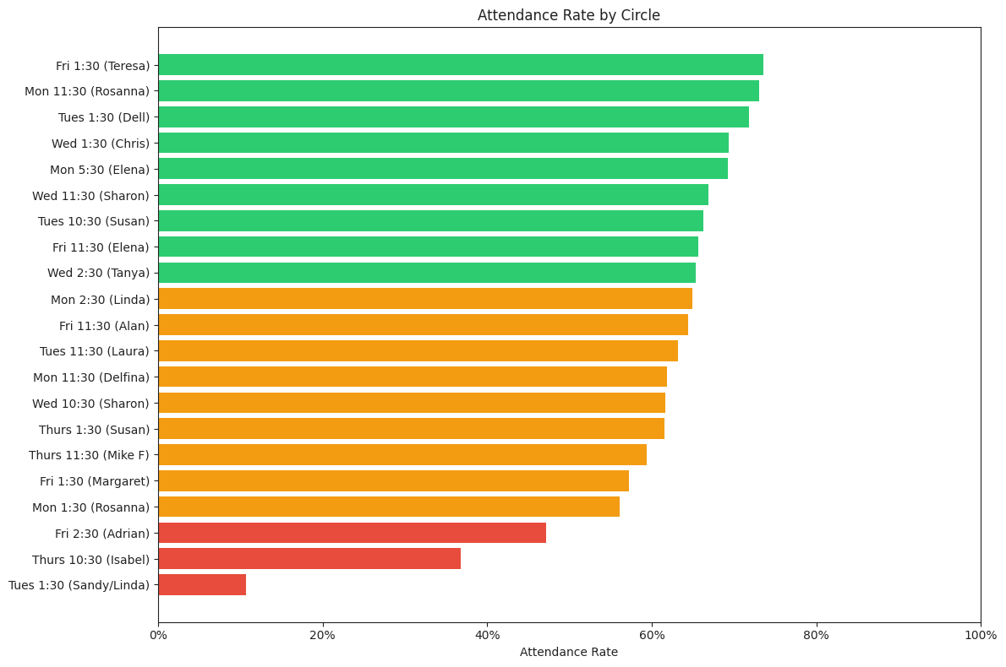

 | circle | members | weeks_with_records | total | present | attendance_rate
0 | Fri 1:30 (Teresa) | 15 | 12 | 144 | 106 | 0.7
1 | Mon 11:30 (Rosanna) | 17 | 12 | 119 | 87 | 0.7
2 | Tues 1:30 (Dell) | 12 | 14 | 78 | 56 | 0.7
3 | Wed 1:30 (Chris) | 19 | 14 | 173 | 120 | 0.6
4 | Mon 5:30 (Elena) | 7 | 14 | 26 | 18 | 0.6
5 | Wed 11:30 (Sharon) | 24 | 14 | 181 | 121 | 0.6
6 | Tues 10:30 (Susan) | 21 | 14 | 175 | 116 | 0.6
7 | Fri 11:30 (Elena) | 24 | 13 | 172 | 113 | 0.6
8 | Wed 2:30 (Tanya) | 18 | 14 | 176 | 115 | 0.6
9 | Mon 2:30 (Linda) | 17 | 13 | 117 | 76 | 0.6
10 | Fri 11:30 (Alan) | 17 | 12 | 121 | 78 | 0.6
11 | Tues 11:30 (Laura) | 18 | 14 | 136 | 86 | 0.6
12 | Mon 11:30 (Delfina) | 18 | 12 | 131 | 81 | 0.6
13 | Wed 10:30 (Sharon) | 21 | 14 | 141 | 87 | 0.6
14 | Thurs 1:30 (Susan) | 19 | 13 | 143 | 88 | 0.6
15 | Thurs 11:30 (Mike F) | 21 | 13 | 138 | 82 | 0.5
16 | Fri 1:30 (Margaret) | 22 | 13 | 138 | 79 | 0.5
17 | Mon 1:30 (Rosanna) | 17 | 13 | 114 | 64 | 0.5
18 | Fri 2:30 (Adrian) | 20 | 11 | 87 | 41 | 0.4
19 | Thurs 10:30 (Isabel) | 4 | 6 | 19 | 7 | 0.3
20 | Tues 1:30 (Sandy/Linda) | 8 | 10 | 28 | 3 | 0.1

Attendance Rate by Circle by Month (Heatmap)
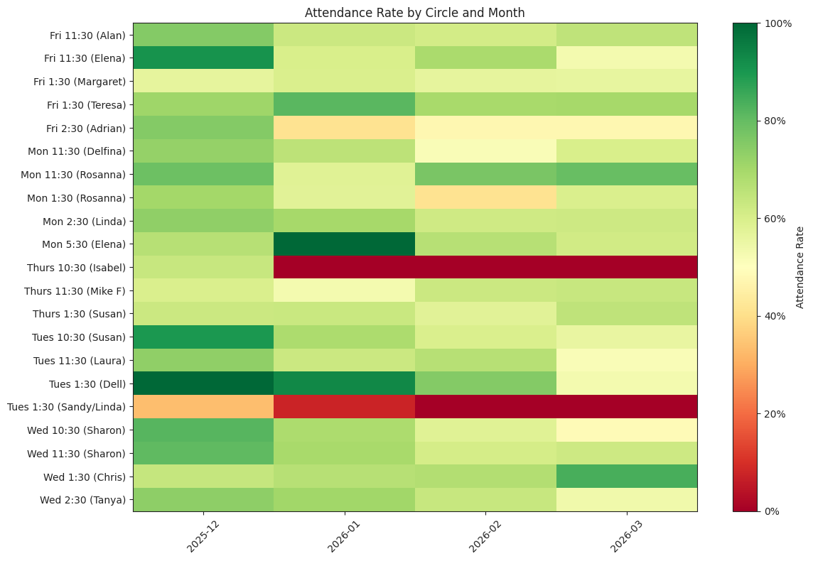

Weekly Attendance Trend
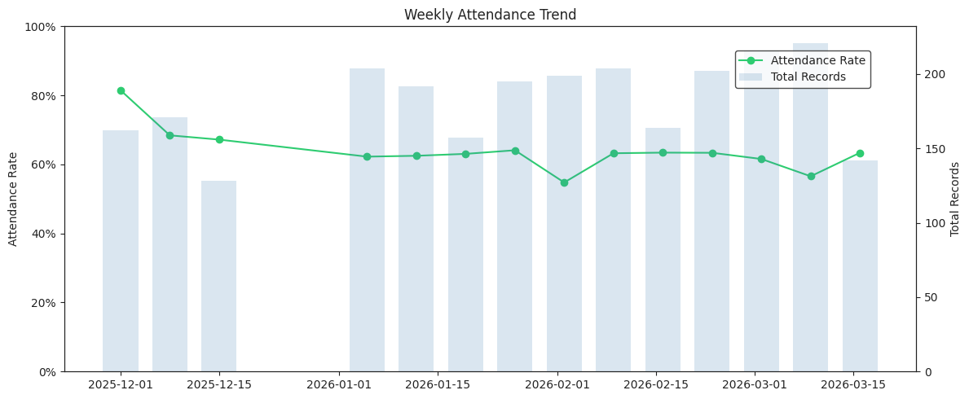

Disenrollments
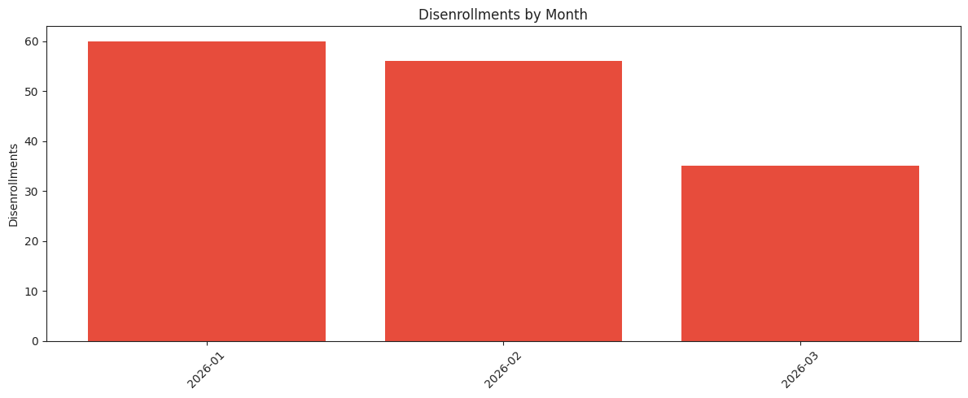

 | month | count | month_str
0 | 2026-01 | 60 | 2026-01
1 | 2026-02 | 56 | 2026-02
2 | 2026-03 | 35 | 2026-03
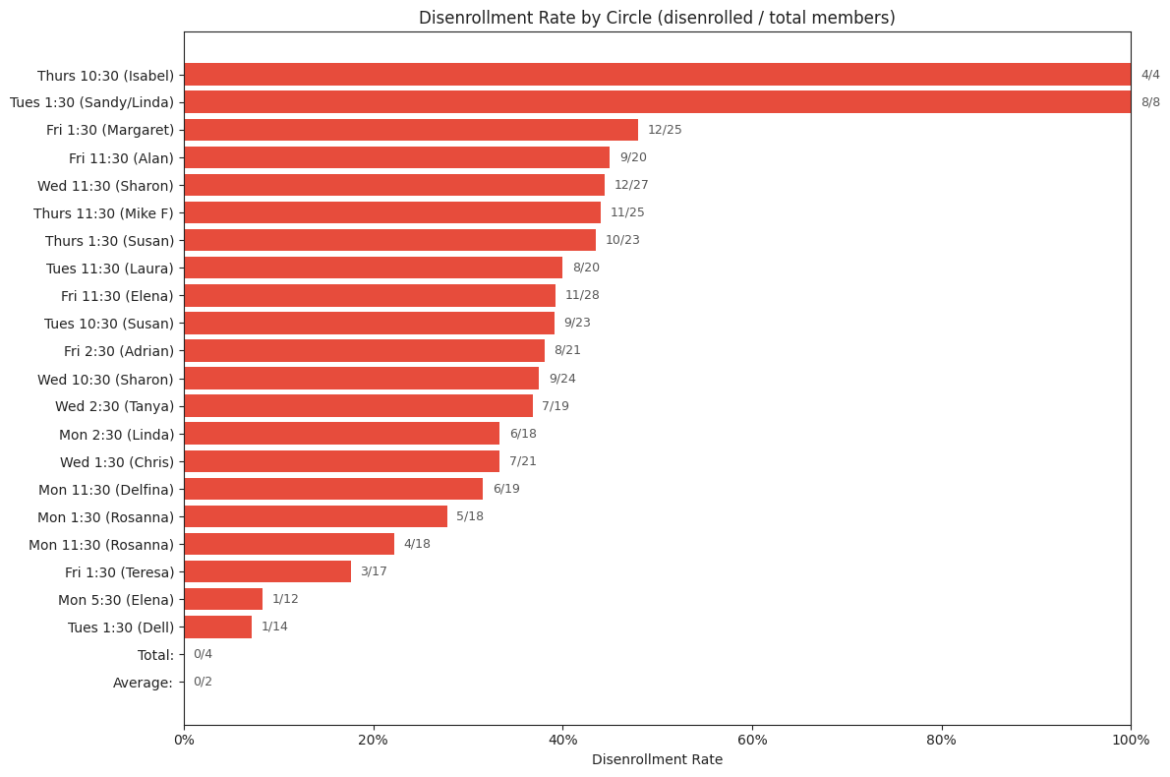

 | circle | total_members | disenrolled | disenrollment_rate
11 | Thurs 10:30 (Isabel) | 4 | 4 | 1.0
18 | Tues 1:30 (Sandy/Linda) | 8 | 8 | 1.0
3 | Fri 1:30 (Margaret) | 25 | 12 | 0.4
1 | Fri 11:30 (Alan) | 20 | 9 | 0.4
20 | Wed 11:30 (Sharon) | 27 | 12 | 0.4
12 | Thurs 11:30 (Mike F) | 25 | 11 | 0.4
13 | Thurs 1:30 (Susan) | 23 | 10 | 0.4
16 | Tues 11:30 (Laura) | 20 | 8 | 0.4
2 | Fri 11:30 (Elena) | 28 | 11 | 0.3
15 | Tues 10:30 (Susan) | 23 | 9 | 0.3
5 | Fri 2:30 (Adrian) | 21 | 8 | 0.3
19 | Wed 10:30 (Sharon) | 24 | 9 | 0.3
22 | Wed 2:30 (Tanya) | 19 | 7 | 0.3
9 | Mon 2:30 (Linda) | 18 | 6 | 0.3
21 | Wed 1:30 (Chris) | 21 | 7 | 0.3
6 | Mon 11:30 (Delfina) | 19 | 6 | 0.3
8 | Mon 1:30 (Rosanna) | 18 | 5 | 0.2
7 | Mon 11:30 (Rosanna) | 18 | 4 | 0.2
4 | Fri 1:30 (Teresa) | 17 | 3 | 0.1
10 | Mon 5:30 (Elena) | 12 | 1 | 0.0
17 | Tues 1:30 (Dell) | 14 | 1 | 0.0
14 | Total: | 4 | 0 | 0.0
0 | Average: | 2 | 0 | 0.0

Attendance Before Disenrollment
How did disenrolled members' attendance look in their final weeks?
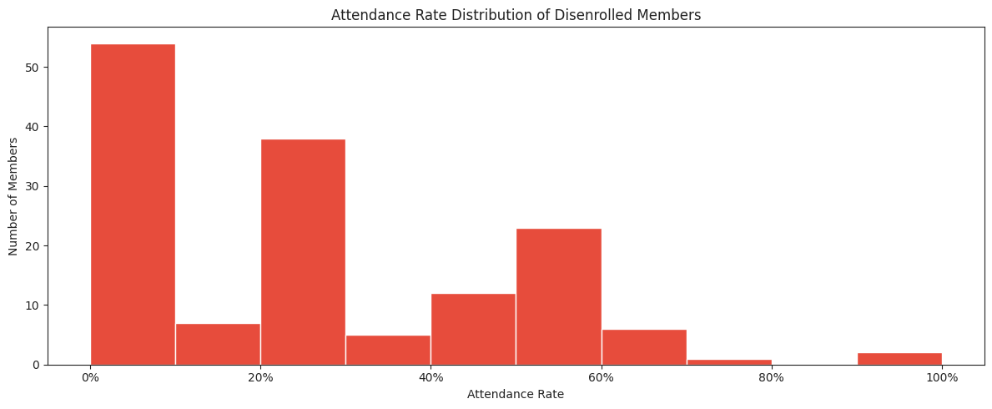
Median attendance rate of disenrolled members: 25%
Mean attendance rate of disenrolled members: 24%

Current Members at Risk
Active members with attendance rates similar to those who were disenrolled.
26 current members with attendance below 50%:

 | full_name | circle | weeks_tracked | present | absent | attendance_rate
1 | Abreham Wolde | Tues 1:30 (Dell) | 2 | 0 | 2 | 0.0
194 | Steven Cuevas | Tues 11:30 (Laura) | 2 | 0 | 2 | 0.0
190 | Stacey Green | Fri 2:30 (Adrian) | 2 | 0 | 2 | 0.0
169 | Ramon Ayala | Tues 1:30 (Dell) | 2 | 0 | 2 | 0.0
144 | Michael Maxey | Wed 10:30 (Sharon) | 2 | 0 | 2 | 0.0
136 | Maria Ramirez | Mon 5:30 (Elena) | 1 | 0 | 1 | 0.0
116 | Kimi Baxter | Wed 10:30 (Sharon) | 2 | 0 | 2 | 0.0
131 | Marco Celestino | Mon 11:30 (Rosanna) | 2 | 0 | 2 | 0.0
201 | Triza Aurora | Fri 2:30 (Adrian) | 1 | 0 | 0 | 0.0
88 | Jeremiah Robles | Mon 5:30 (Elena) | 1 | 0 | 1 | 0.0
74 | Harlan Graves | Fri 2:30 (Adrian) | 3 | 0 | 3 | 0.0
66 | Gabriel Richardson | Fri 1:30 (Margaret) | 1 | 0 | 0 | 0.0
114 | Kenneth Jackson | Thurs 11:30 (Mike F) | 1 | 0 | 1 | 0.0
197 | Terrance Bonilla | Wed 10:30 (Sharon) | 3 | 1 | 2 | 0.3
25 | Brian Rucker | Tues 1:30 (Dell) | 3 | 1 | 2 | 0.3
189 | Siobhan Williams | Wed 2:30 (Tanya) | 9 | 3 | 4 | 0.3
170 | Ramon Ramirez | Wed 10:30 (Sharon) | 3 | 1 | 2 | 0.3
115 | Kimi Baxter | Tues 1:30 (Dell) | 3 | 1 | 2 | 0.3
143 | Michael Maxey | Tues 1:30 (Dell) | 3 | 1 | 2 | 0.3
130 | Manny Salazar | Fri 11:30 (Elena) | 3 | 1 | 0 | 0.3
57 | Elizabeth Chavez | Fri 1:30 (Teresa) | 5 | 2 | 3 | 0.4
156 | Noah DeCiercq | Fri 2:30 (Adrian) | 10 | 4 | 6 | 0.4
177 | Ruben Mejias | Mon 1:30 (Rosanna) | 12 | 5 | 6 | 0.4
199 | Tim Fulwood | Mon 11:30 (Delfina) | 12 | 5 | 7 | 0.4
33 | Chris Seong | Mon 1:30 (Rosanna) | 12 | 5 | 0 | 0.4
118 | Lagi Tuaimalo | Tues 10:30 (Susan) | 7 | 3 | 4 | 0.4

