survey_completion.clean

Survey Completion Tracking
How many surveys should we have done vs how many we actually did?
Covers the 12-month period ending today. Accounts for member enrollment and disenrollment dates. Uses the Sheets Current Roster as gold standard for disenrollment; falls back to Agency end dates for members not on the roster.

1. Membership Activity in the Period

Membership Summary (2025-03-19 to 2026-03-19)
Metric | Count
Members active at any point in the period | 717
New enrollments during the period | 567
Disenrollments during the period | 509
Currently active (as of 2026-03-19) | 171

2. Scheduled vs Actual Survey Completion
If every member received their initial survey at enrollment, plus all scheduled follow-ups (3/6/9/12 month and annual) while enrolled, how many surveys should we have done — and how many did we actually do?
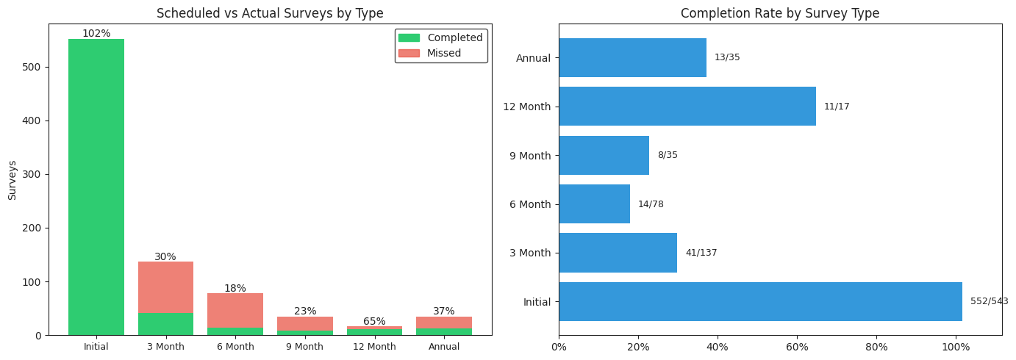
Survey Type | Scheduled | Actual | Rate
Initial | 543 | 552 | 102%
3 Month | 137 | 41 | 30%
6 Month | 78 | 14 | 18%
9 Month | 35 | 8 | 23%
12 Month | 17 | 11 | 65%
Annual | 35 | 13 | 37%
Total | 845 | 639 | 76%

3. Follow-up Workload by Week
When were follow-up surveys due over the past 12 months? Each member's milestones are calculated from their enrollment date (3/6/9/12 months for first-year members, annually thereafter). Milestones are not counted for members who were disenrolled before the due date.
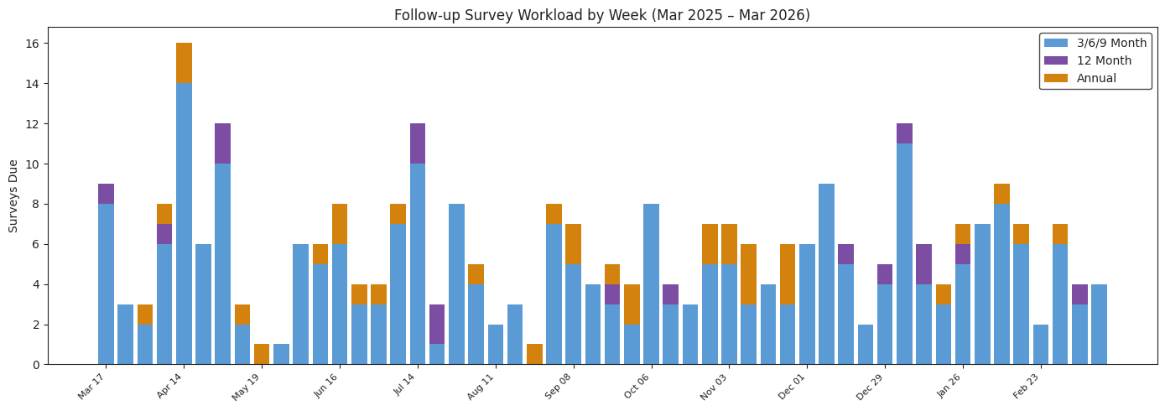

4. Monthly Survey Workload
How many surveys were due each month vs how many were actually recorded? Scheduled counts include initial surveys (pinned to the member's enrollment date) plus all follow-up milestones that fell due that month. Members who were disenrolled before a milestone's due date are excluded from the scheduled count.
